# Link Budget Equations

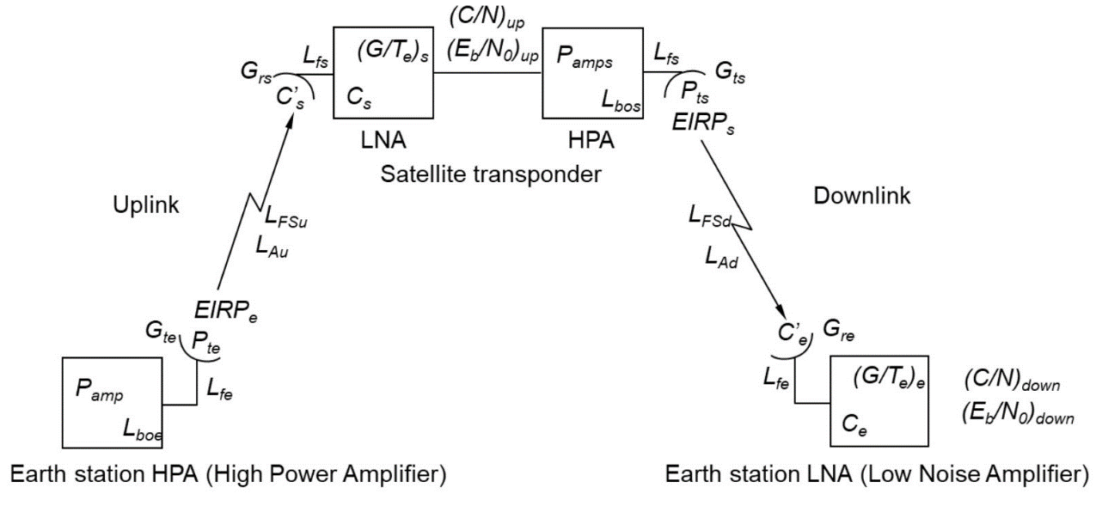

Transmitter EIRP (EIRP) [dB] – *EIRP* = $P_{amp}$– $L_{bo}$– $L_{f}$ + $G_{t}$

$P_{amp}$– Transmitter Power (dBW)

$L_{bo}$– Back-off Loss (earth station only – for this assignment assume to be 0)

$L_{f}$– feeder Loss (dB)

$G_{t}$– Transmitter antenna Gain (dB)

Free Space Loss ($L_{FS}$) [dB] – $L_{FS}$ = -92.44-20*log($ⅆ_{s}$. $f$)

$ⅆ_{s}$ = slant range (kms)

$f$ = frequency (GHz)

Carrier Power Density (C’) [dBW] – C’ = *EIRP* – $L_{FS}$– $L_{A}$

*EIRP* – Effective Isotropic Radiated Power (dB)

$L_{FS}$– Free space Loss (dB)

$L_{A}$– Atmospheric Loss (dB)

Equivalent Noise Temperature (Te) [K] – $T_{e}$ = T*(NF-1)

T – Receiver Environmental temperature (K)

NF – Receiver Noise Figure

Equivalent Noise Temperature (Te) [dBK] – $T_{e}$ [dBK] = 10*log($T_{e}[K] )$

Receiver G/ $T_{e}$ (G/ $T_{e}$) [dB $K^{-1}$] – G/ $T_{e}$ = $G_{r}$/ $T_{e}$ = $G_{r}$- $T_{e}$ $T_{e}$*is minus as values are in dB

$G_{r}$*

– Receiver Antenna Gain (dB)

$T_{e}$– Equivalent Noise Temperature (dBK)

C/N0 ratio [dB] – C/No = $C^{'}-10.\log\left(k\right)+\frac{G}{Te}-L_{fr}$

C’ – Carrier Power Density (dBW)

$L_{fr}$– Receiver feeder Loss (dB)

*k* – Boltzmann’s constant (1.36 ${10}^{-23}$ $Jk^{-1}$* )

Eb/No Ratio [dB] – Eb/No = C/No – 10log($f_{b}$)

$f_{b}$– maximum bit rate (bit/s)

# From Edwins method

Noise Density [dBW/Hz] – $N_{0}=\frac{G}{T_{e}}-k-L_{rf}$

$G_{r}$– Receiver Antenna Gain (dB)

$T_{e}$– Equivalent Noise Temperature (dBK)

$L_{fr}$– Receiver feeder Loss (dB)

*k* – Boltzmann’s constant (1.36 ${10}^{-23}$ $Jk^{-1}$* )

Raw bit rate [bit/s] – $R_{b}=SF*\frac{BW}{2*SF}$

SF – Spreading factor

BW – Bandwidth (Hz)

Effective bit rate [bit/s] – $R_{b eff}=R_{b}*FEC$

$R_{b}$– Raw bit rate (bit/s)

FEC – Forward error correction code rate

Bandwidth efficiency [bit/Hz] – $η=\frac{R_{b}}{BW}$

$R_{b}$– Raw bit rate (bit/s)

BW – Bandwidth (Hz)

Total Noise Power [dBw] –

- Noise density (dBw/Hz)

BW – Bandwidth (Hz)

Carrier to Noise [dB] – $\frac{C}{N}=C^{'}-N$

C’ - Carrier Power Density (dBw)

N – Total noise power (dBw)

Eb/No ratio [dB] – $\frac{E_{b}}{N_{0}}=\frac{C}{N}+10\log_{10}\left(\frac{BW}{R_{b eff} }\right)$

$\frac{C}{N}$– Carrier to Noise (dB)

BW – Bandwidth (Hz)

- Effective Bit Rate (bit/s)